# Introduction





# Supervised and Unsupervised Learning

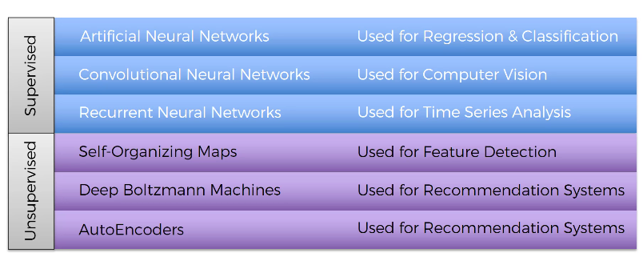

# Codes and Datasets

<https://www.superdatascience.com/deep-learning>

# Location of many datasets:

<https://archive.ics.uci.edu/datasets>

# Plan



# Part 1 – Artificial Neural Networks

## Neurons



Neurons in human mind.





Dendrites – receivers of the signals

Axon – transmitter of the signals







In case of humans, input neurons are like 5 senses.







## Normalization and Standardization

Read ‘Normalization and Standardization.docx’





In case of categorical output, you need multiple output neurons (one for each category).



If you only had **1 output neuron**, it couldn’t distinguish among **3+ classes** — it can only give a yes/no signal.





Weights get adjusted during the process of training the Neural Network. That is when Gradient Descent and Back Propagation come into play.



What happens in the neuron?



First step is to just do x1w1+x2w2+…..+xmwm



Second step is to apply Activation Function.



Third step is passing the data to the next neuron down the line.



## Activation Function



Activation function is applied on hidden layers and output layer.

### Threshold Function



If  is <0, threshold function returns 0, otherwise it returns 1. There is no in between value.

### Sigmoid Function



Sigmoid function . This function is also used in Logistic Regression. It is very useful for output layer. It returns any value in between 0 and 1. Unlike to Threshold Function, it is not exactly 0 or 1. If it is close to 0, it is considered 0. If it is close to 1, it is considered 1.

### Hyperbolic Tangent (tanh) Function



It is very much similar to Sigmoid Function. Instead of 0 to 1, it goes from -1 to 1. It is zero-centered.

### ReLU (Rectified Linear Unit) Function



Rectifier function. It is one of the most used and important Activation Function.

### Leaky ReLU (Parametric ReLU)

From Neural Network.docx document



 is a very small positive constant like 0.01, 0.02.



### More Information



### Which Activation Function to use?

If Dependent Variable is binary, 0 or 1, which activation function would you use.





## How do NNs work?

### Step-by-Step Guide to Property Valuation Example



This is the simplest form of NN.

Hidden layer gives us the extra power.



For this neuron, Area and Distance to city are important, so they will have non-zero weights, whereas Bedrooms and Age will have zero weights.



This particular neuron is looking for the houses which are not so far from the city and have large areas.

Let’s just get rid of lines having zero weights.





This neuron is interested in Area, Bedrooms and the Age of the property (house). There are people looking for new and large house with many rooms. They are not interested in how far it is from the city.



This neuron can pick up the properties which are very old (> 100 years) and historical. There are people who are interested in these kind of properties. ReLU activation function is perfectly suitable for this neuron. Till 100 years of age, it returns 0 and then it returns higher value as age of the property increases.











### How to decide number of hidden layers and neurons?

#### Number of Neurons in Hidden Layers

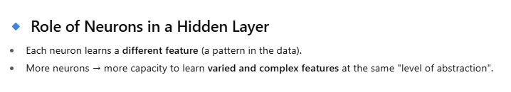

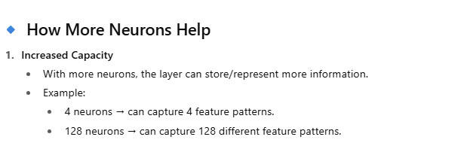

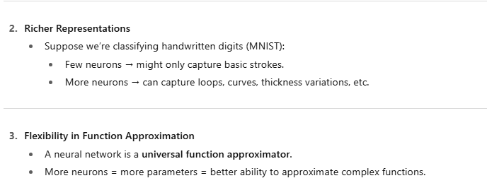

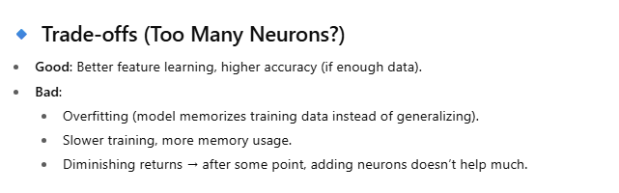

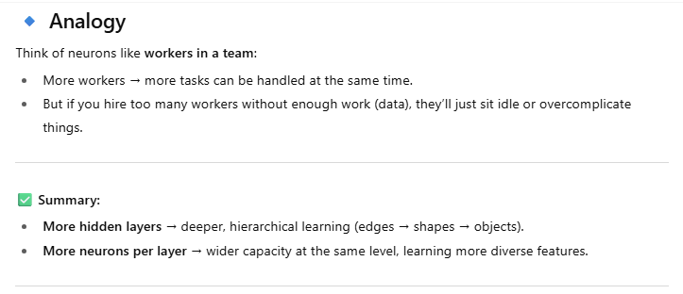

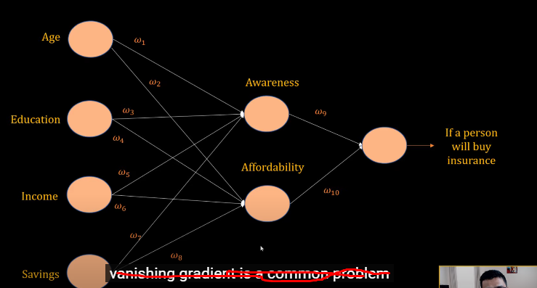

#### Number of Hidden Layers

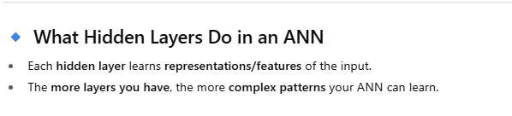

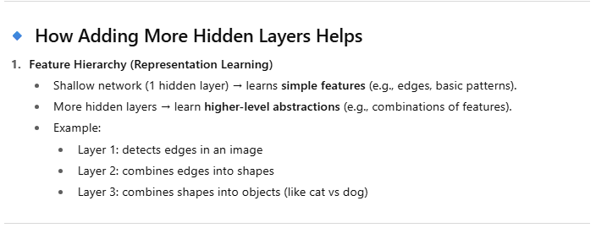

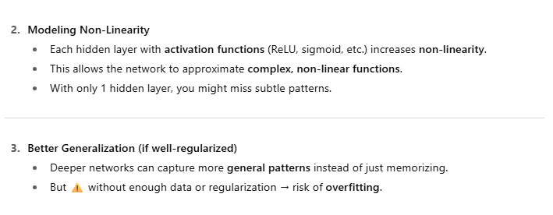

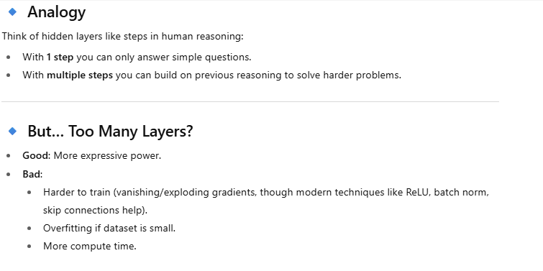

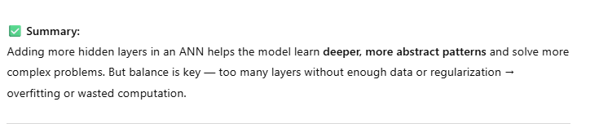

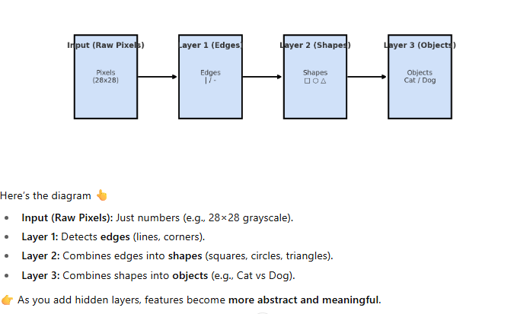

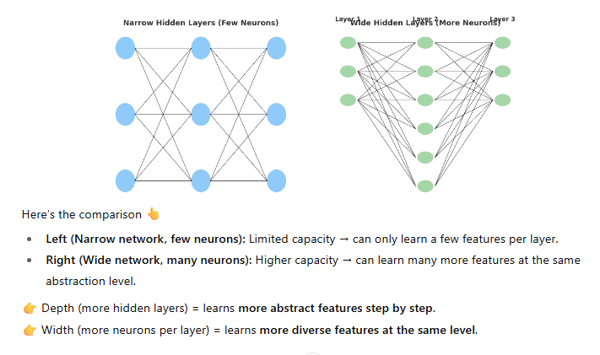

## How do NNs Learn?

### Understanding Backpropagation and Cost Functions



Single layer NN is called a Perceptron.



We need to compare the output value (predicated value) with actual value.



If you see, there is a little bit of difference between output value and actual value.



We are going to calculate the cost function (loss function) . It is basically telling you the error by taking the difference of predicated value and actual value. Our goal is to minimize this error.



This error information is fed back to NN and weights will be updated.



We are dealing with just one row(observation).



We feed these values to NN.



Based on cost function’s value (error), all weights get adjusted to reduce the error.

We feed this row (observation) again and again, so that cost function and weights are optimized.









Now, let’s take multiple rows (observations). There is just one NN. Here, 8 NNs are shown for 8 rows for simplicity.

One EPOCH is feeding all the rows once to NN.



There is first row and there is output value for the first row on the chart.



There is second row and there is output value for the second row on the chart.



Third row.



Fourth row.



And so on…



Then we compare with the actual values.



Then we calculate the cost function from all these output values and actual values.

Once we have the value of cost function, we go back and update the weights.



There is just one NN. For all the rows, weights are updated and all the rows share those weights.

We do the same process of feeding the rows, finding the cost function and updating the weights again and again. Goal is to minimize the cost function.

This whole process is called **BACKPROPAGATION**.

### Additional Reading



## Gradient Descent



Let’s learn how to minimize the cost function and how these weights are adjusted.



This is how cost function chart looks like for different output values. This is a brute-force approach, where we try thousands of different values of weights and find out which one works the best. As number of inputs increases, this becomes more and more complex and you face the Curse of Dimensionality.

What is the Curse of Dimensionality?

Before we train the NN, it looks like below



After training, it looks like below (after weights are adjusted)



If we use a brute-force approach, a super computer can take years to calculate the weights.



Our NN is very simple, what if a NN looks like this?



So, the method that we are going to look at is called Gradient Descent.

This is our cost function chart





Let’s start from some point. Find out whether the slope at that point is +ve or –ve. If slope is –ve, it means you are going downhill. So, you need to go right.



This time the slope is +ve. So, you need to go left.



Again calculate the slope. Go to right.



That’s how you find the best point that minimizes your cost function (and adjusted weights).



2-D picture of Gradient Descent



3-D picture of Gradient Descent



## Stochastic Gradient Descent



Previously, we learned about Gradient Descent and we found out that it is a very efficient solution to solve optimization problem where we are trying to minimize the cost function. It requires the cost function to be convex. What if our cost function is not convex? If we choose the cost function that is not square of y and y^ or if it is a multidimensional space, then the cost function may not be convex.





In this case, we will find the local minimum rather than a global minimum. In this case, we will not have the most optimized cost function and so weights and so NN.

Answer here is the **Stochastic Gradient Descent**. Stochastic Gradient Descent doesn’t require the cost function to be convex.



In normal Gradient Descent (or Batch Gradient Descent), we feed all the rows to NN, we calculate the cost function and we adjust the weights.



In Stochastic Gradient Descent, we take one row, feed it to NN, calculate the cost function and adjust the weights.



Now, second row and so on.

This is one Epoch. Do this again and again to adjust the weights better.



Stochastic Gradient Descent has more fluctuations. So, there is a higher chance to find a Global minimum rather that a local minimum.

You may feel that Stochastic Gradient Descent should be slower because it is calculating cost function after every row. But actually, it is faster because it doesn’t have to load the entire data into memory and wait until all the rows are run together.

Stochastic means random. Every time, you run a Batch Gradient Descent, you get the same results (weights), but that’s not true in case of Stochastic Gradient Descent.

There is a in between Gradient Descent method also – Mini Batch Gradient Descent. You set the number of rows that should be fed to NN together.

### Additional Reading





## Backpropagation



During Backpropagation, all the weights are updated together.

### Additional Reading



### Training the ANN with Stochastic Gradient Descent



## How to decide number of neurons and hidden layers?

How to decide number of neurons (units)?

Unfortunately, there is no rule of thumb. You just need to try different numbers and pick the one that works better.

How to decide number of hidden layers?

There's no hard and fast rule for the exact number of hidden layers, but as a general guideline:  
 Simple tasks: One or two hidden layers might be enough.   
 Complex tasks: Deep learning models with several hidden layers (e.g., 3 or more) are often necessary.

For simple tasks, a single hidden layer may suffice, while more complex tasks, like image recognition or natural language processing, often require multiple hidden layers.

Deep learning, which involves networks with multiple hidden layers, is frequently used for these more complex problems.

If you add just one hidden layer, it creates a shallow NN.  
So, create at least two hidden layers to create a deep NN.

Single Hidden Layer:  
Neural networks with one hidden layer can effectively solve many problems, especially those involving linearly separable data or relatively simple patterns.

Multiple Hidden Layers (Deep Learning):  
As the complexity of the task increases, adding more hidden layers allows the network to learn more intricate relationships and features within the data.   
Deep learning, which is characterized by multiple hidden layers, is particularly useful for tasks that require high levels of abstraction and representation learning.   
  
Overfitting:  
Adding too many layers can lead to overfitting, where the network learns the training data too well and doesn't generalize effectively to new, unseen data.

Practical Considerations:  
When determining the number of hidden layers, factors like the size and complexity of the dataset, the desired accuracy, and computational resources available should be considered.   
  
Empirical Approach:  
Often, the best approach is to start with a reasonable number of layers and then experiment, monitoring performance on a validation set to find the optimal architecture for a given task.

For all the hidden layers, activation function must be ReLU or 'Leaky ReLU)

## Building an ANN

NOTE: Install Microsoft Visual C++ latest version on your computer. Tensorflow needs it.

### Classification Problem



We are going to look at the Classification example. Another free course has regression example.

<https://www.udemy.com/course/linear-regression-with-artificial-neural-network/>

Last column is a dependent variable.

This is the data provided by bank about its customers. We will get rid of the variables which are not useful.

Exited=0 means customer is still with the bank, 1 means customer exited the bank.

Code is in PythonProj.

### Regression problem

<https://www.udemy.com/course/linear-regression-with-artificial-neural-network/>

DataSet place

<https://archive.ics.uci.edu/dataset/294/combined+cycle+power+plant>







# Part 2 – Convolutional Neural Networks (CNN)



## How do CNNs work?



Based on how you see this picture, you may see either a young lady or an old lady.

Is it a duck or rabbit? It depends how does your mind processes this image.



One more example.



CNN gives for possibilities to first picture. Among these four, Cheetah gets the highest vote. So, CNN decides it Cheetah.



CNN is taking over ANN.



Jeoffrey Hintons is a father of ANN. His student, Yann Lecun, is a father of CNN.









B/W image is a 2d array of pixel value between 0 and 255. 0 is completely black pixel and 255 is completely white pixel.

Colored image is a 3d array of blue layer, green layer and red layer. Each pixel has 3 values assigned to it.



If we consider 0 as white and 1 as black, this is how the image is represented in pixel values.



### Additional Reading



## Convolutional Filters



Convolution function





























Does the filter/kernel/feature detector have to be 3x3 matrix only?

No



















What is feature map?

Human mind doesn’t look at the pixels. It looks at the features in the image. In cheetah, we look at black spots, eyes etc. Feature Map is a map of features.

By creating a feature map, we have reduced the size of an image. It becomes easier and faster to process it.

















Many filters are applied and many feature maps are created to obtain our first convolution layer.



There are some examples of filters applied on image on <https://docs.gimp.org/2.8/en/plug-in-convmatrix.html>













## ReLU Layer



We want to increase **non-linearity** in our network, so we apply an activation function. Images by nature are non-linear, but when we apply filters and create feature maps, there is a risk that we might bring linearity in it. So, we apply activation function to bring non-linearity.











Original image

When we apply feature detector(filter), we may get something like this.





ReLU removes all the blacks (anything below 0 returns 0)

In original image, there is white and grey and darker grey and black. So, there is a linear progression in the color. By removing the black color, ReLU breaks the linearity.



Same thing is here. White, grey, black.



By ReLU, that linearity is broken.







## Max Pooling (Understanding Spatial Invariance in CNNs)





We want our NN to recognize Cheetah in every single of these images.

You may have fed images of cheetah to our NN. But other Cheetah pictures may have same features but they appear little differently. Cheetah might be looking at some other direction, sleeping or standing etc. Our NN should be able to recognize these pics as Cheetah regardless of distortions in features. This is called Spatial Invariance. Max Pooling helps in that.









…



In feature map, big numbers represent more important features. So, we will preserve them by doing max pooling. We can get rid of big part of feature map that is not important features that we are looking out for.

In feature map, let’s say 4 represents tear mark of cheetah. If these tear marks would have little bit rotated in the pic, 4 would have ended up in a cell (2,0) in feature map, pooled feature map would have still captured it.

Max Pooling helps you in two things.

* It reduces the size of feature map. So, processing becomes faster. We are preventing overfitting.
* It preserves important features even though they are distorted in pictures.



Types of pooling











Convolution layer detects the features in the picture using filters. Pooling layer further filters the features to keep only important ones and getting rid of the rest.

<https://adamharley.com/nn_vis/cnn/2d.html>



This tool is trained only for 0 to 9. So, any shape you draw, it will try to recognize as some number from 0 to 9.

## Difference between Filtering and Pooling













## Flattening (flattening pooled feature maps)



We flatten all pooled feature maps and make them ready as inputs to ANN.





## Fully Connected Layers



After filtering, pooling and flattening, we are adding ANN.

More realistic ANN



Here, there are only two categories – Dog and Cat. So, it’s a binary classification and we can have only one output neuron in that case. But here, we are taking two neurons just for practice. If you have more than two classes, then you have to have that many neurons in the output layer.



When Backpropagation happens, along with weights in ANN, Feature Detectors (filters/kernels) are also updated. There is a lot of mathematics how it is done. It all happens behind the scene.



Hypothetically, we have assigned some numbers to neurons. 1 means it is very confident about some feature like nose/ears/eyebrows. Now, this information is passed to both Dog and Cat neurons. Let’s say a picture that was passed to CNN has a label Dog. Then this Dog neuron will remember that important information about the Dog features will be found in 1st, 2nd and 6th neuron. Cat neuron will remember that these 1st, 2nd and 6th neurons do not contain the features information for a Cat.

When we are training the model with lots and lots of pictures, when 1st, 2nd and 6th neurons are fired up most of the time when that picture is of the Dog, then Dog neuron will learn that whenever 1st, 2nd and 6th neurons are fired up, then that is for me. And Cat neuron will learn that it should ignore 1st, 2nd and 6th neurons.

Dog neuron will start giving higher importance to 1st, 2nd and 6th neurons.



When it is actually a Cat picture



3rd, 5th and 8th neurons will fired up. Cat neuron will learn from so many epochs that when these neurons are fired up, most of the times it’s a picture of Cat. So, Cat neuron is going to pay more attention to 3rd, 5th and 8th neurons.

At this point, Dog and Cat neurons learned what neurons in the fully connected NN are important for them.

Now, let’s say we passed a picture of a Dog to this NN and 1st, 2nd, 5th and 6th neurons are fired up.



Probability of Dog’s picture is higher than Cat.



So, the first choice of this picture is a Dog and second choice is a Cat.

2nd, 4th, 5th, 8th neurons are fired up. So, there is a higher probability that this picture is of the Cat.



That is how following pictures are voted.



## Summary: CNN Building Blocks (Feature Maps, ReLU, Pooling, Fully Connected Layers)



We apply Feature Detectors (filters/kernels) during Convolution process. It creates lots of Feature Maps. These Feature Maps creates a convolutional layer.

ReLU is applied on these Feature Maps to bring in non-linearity.

Max Pooling is applied to preserve the main features of the picture and reduce the size of Feature maps.

Flattening is applied to make pooled data flat in one column.

These flat data is passed to ANN. From the final hidden layer, output layer neurons learn which hidden layer neurons are important for them. This happens during lots of Epochs.

During each Epoch, Gradient Descent is invoked and during backpropagation, weights **and filters** are updated.



## Softmax activation function and Cross-Entropy loss function

### Softmax activation function



How these values adds up to 1? Dog and Cat are different neurons and they don’t know anything about each other.



Dog and Cat neurons get some values. We apply softmax activation function on them and that brings values between 0 and 1 and makes sure that they add up to 1.

<https://www.youtube.com/watch?v=MGFdvJDUbeY>



Since Softmax has exponential in the function, we can say that it is a non-linear function.



Softmax activation function is based on Sigmoid activation function only. Sigmoid returns the probability between 0 and 1 for binary classification problem (where there is just one neuron in the output layer).

If there are multiple classes (multiple categories) in the output (multiple neurons in the output layer), sigmoid will return the values between 0 and 1 for each of that neuron, but their sum will not become 1.

Here, Softmax function comes to the picture. It returns the probability between 0 and 1 for each output layer neuron + it makes sure that the summation of those probabilities will be 1.

### Cross-Entropy loss function







In all 3 cases, NN1 is performing better than NN2.

Both NNs predicated 3rd image wrongly, but NN1 still better than NN2.





Classification Error – just tells how many predictions are wrong. Both are 0.33, but we know that NN1 performed better than NN2. So, this kind of error is not giving me enough information about the error rate.

Mean Squared Error(MSE) – It is telling me that NN1’s error rate is 0.25 and NN2’s error rate is 0.71. Way better results.

Cross-Entropy – It is telling me that NN1’s error rate is 0.38 and NN2’s error rate is 1.06. A lot better than MSE.

#### MSE vs Cross-Entropy in Classification Problem (Gradient Vanishing Problem)

Read ‘Gradient Vanishing Problem’ section in ‘Neural Network’ document

<https://www.youtube.com/watch?v=PHP8beSz5o4>

In this video, Geoffrey Hinton explains Softmax and Cross-Entropy.

#### Types of crossentropy loss functions

There are 3 types of crossentropy loss functions

1. binary_crossentropy
2. categorical_crossentropy
3. sparse_categorical_crossentropy















## ImageDataGenerator in Code

Primary goal of ImageDataGenerator class is to augment the images.

### Why image augmentation is required?









### ImageDataGenerator class







One image is transformed and many images will be created.













### flow_from_directory in ImageDataGenerator









### flow() vs flow_from_directory() in ImageDataGenerator







### flow_from_directory() vs image_dataset_from_directory()











## Number of filters/kernels/feature detectors























## Number of convolutional layers





MNIST vs CIFAR-10 images vs Imagenet

































## Performance Metrics











## Optimizers (Gradient Descents)

<https://www.geeksforgeeks.org/deep-learning/optimizers-in-tensorflow/>







## image.img_to_array()









# Part 3 – Recurrent Neural Networks (RNN)







## Introduction

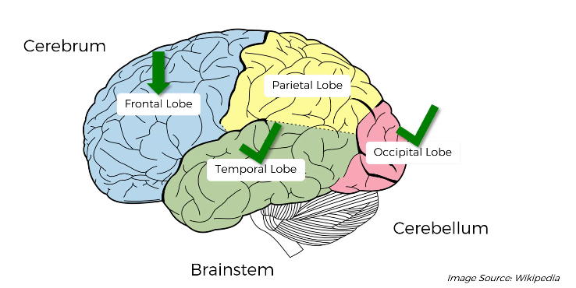

The most important part of ANN is backpropagation (learning by training) and the weights. Weights are the memory. Once ANN is trained, weights remain in the long term memory, just like Temporal Lobe.

So, ANN represents Long-Term memory (Temporal Lobe). ANNs are used of Classification and Regression problems.

CNN is related to image recognition (Occipital Lobe). CNNs are mainly used of image recognition.

RNN is like a Short-Term (temporary) memory (Frontal Lobe). RNNs are mainly used of NLP (Natural Language Processing)

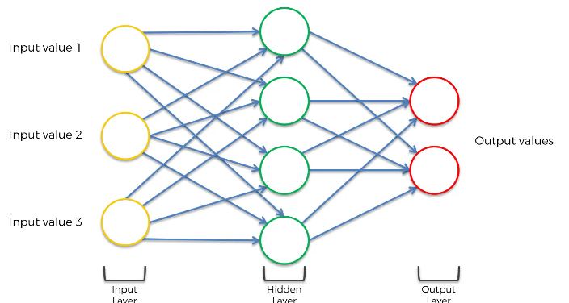

This is our ANN. How do we turn this into RNN?

You squash them altogether. All neurons are still there, they are just flattened out.

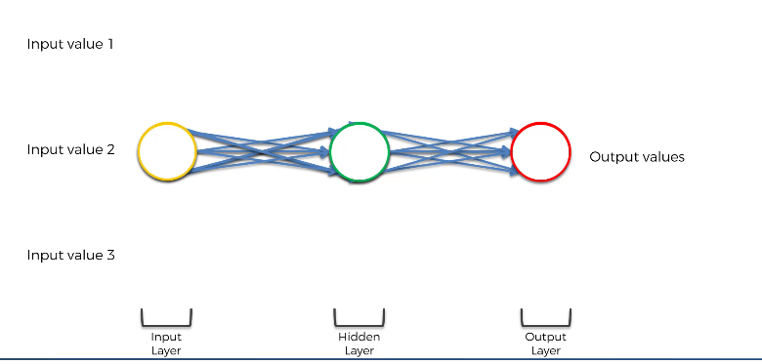

To simplify,

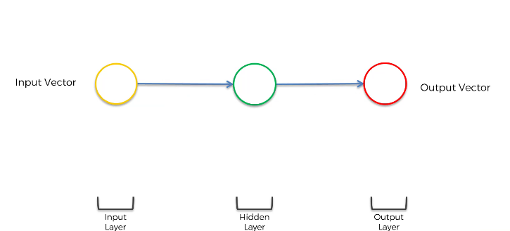

Then, make it vertical because it’s a standard representation.

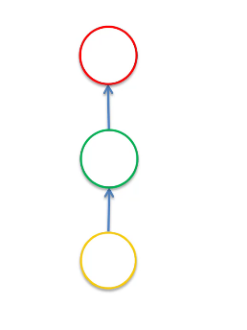

Replace green color in hidden layer with blue and add a line. This line is a Temporal Loop. It means that his hidden layer, not only generates the output, but also it feeds it back to itself.

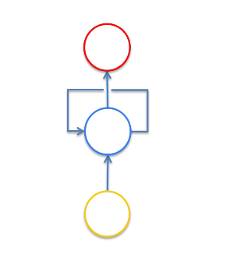

Unroll this temporal loop (same layer) in time and represent ANNs in following manner.

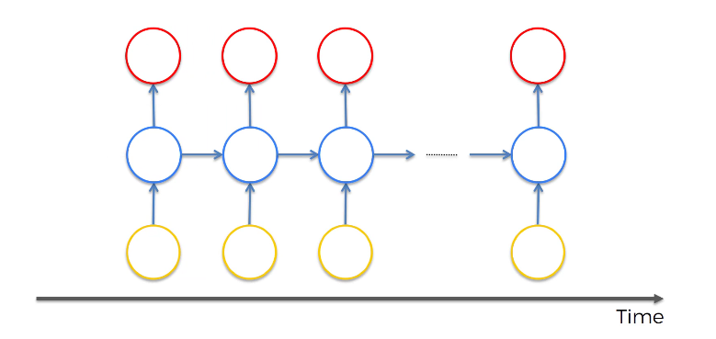

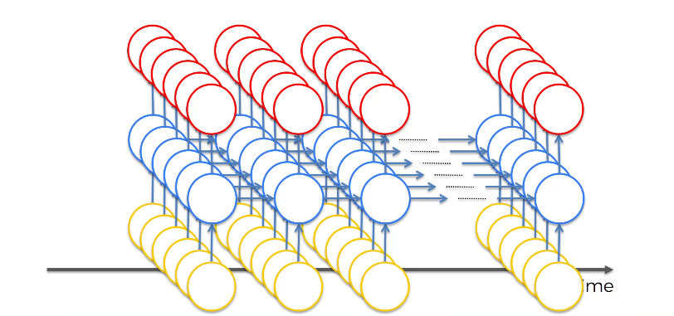

**These are not different NNs. It is just one NN. For every input, a previous output from hidden layer(s) is fed in the same hidden layer(s) along.**

Every neuron in hidden layer has some memory to remember what was there in the previous neuron.

Must watch this video: <https://www.youtube.com/watch?v=Y2wfIKQyd1I>

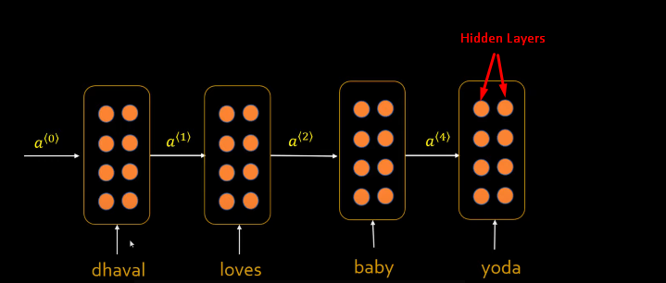

NN can have multiple hidden layers.

One input and multiple outputs (One to Many). Multiple inputs and one output (Many to One).

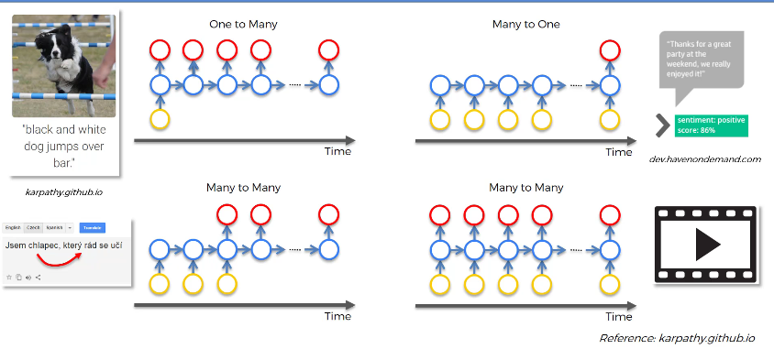

One to Many

This one image is fed to CNN and CNN is connected to RNN. CNN identifies that it’s a dog and then RNN puts a sentence together ‘black and white dog jumps over bar.’

Many to One

One sentence is fed to RNN and RNN analyzes it to predict whether that sentence shows a positive sentiment or a negative sentiment.

Many to Many

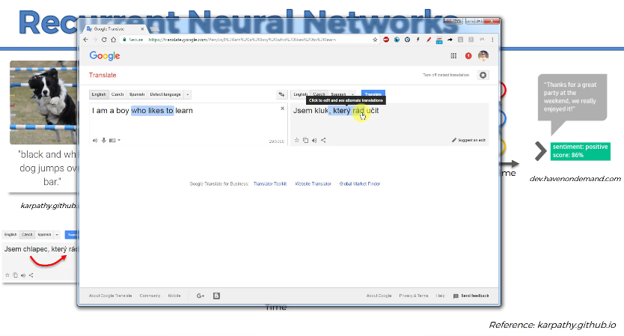

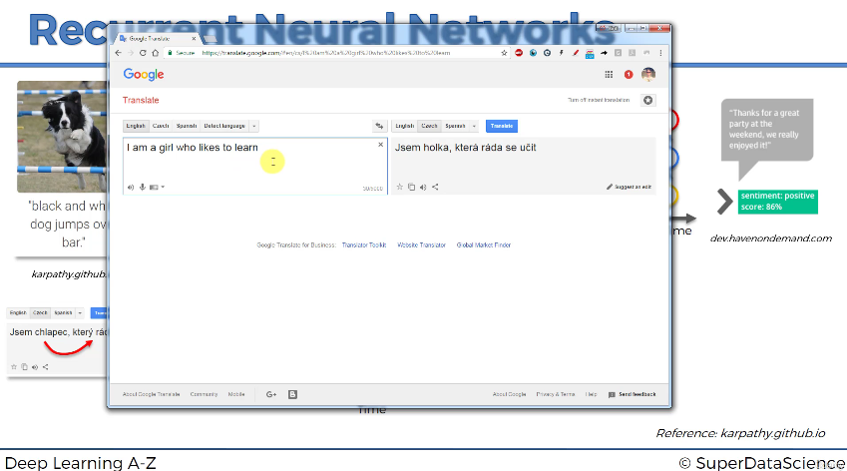

If you look at google translator. If you change the word ‘boy’ to ‘girl’. Then ‘Kluk’ means boy and ‘hotka’ means girl in some other language. But based on these words, next words are also changed. Instead of ‘ktery Rad’, it is ‘ktera rada’. It means that to change the current word, it needs to have knowledge of previous word.

We don’t know whether google translator is an RNN, but the concept is the same.

You can use RNN to subtitle movies also. When you are describing movie, you need to have the context of what happened previously, to describe what is happening now.

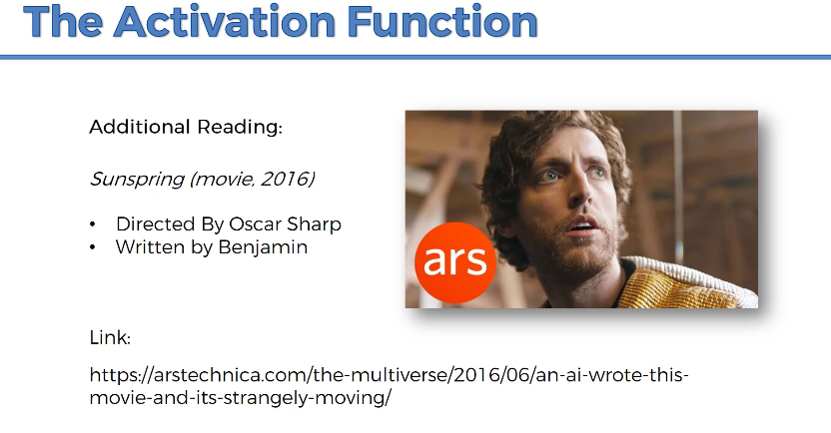

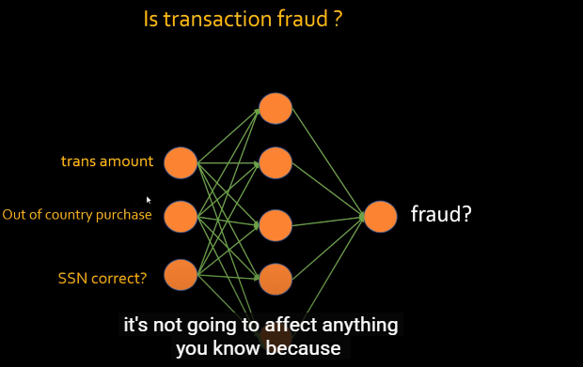

Let’s say, you have ANN. In above example, if you change the sequence of input variables, it doesn’t matter. ANN will be trained accordingly and answer is going to remain same, whether the transaction is fraud or not.

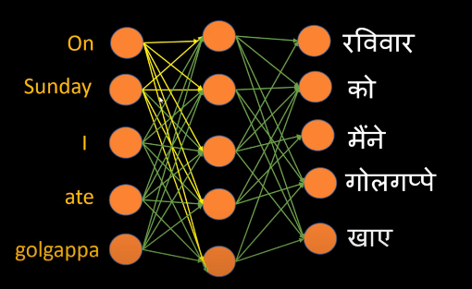

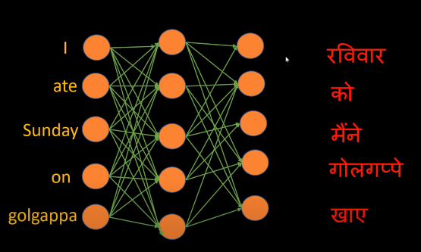

Whereas, in this case, sequence of the input variables matter a lot. Based on the sequence on input variables, output should change. So, we can’t use ANN in this kind of cases.

## Vanishing Gradient

From: <https://www.youtube.com/watch?v=qowp6SQ9_Oo>

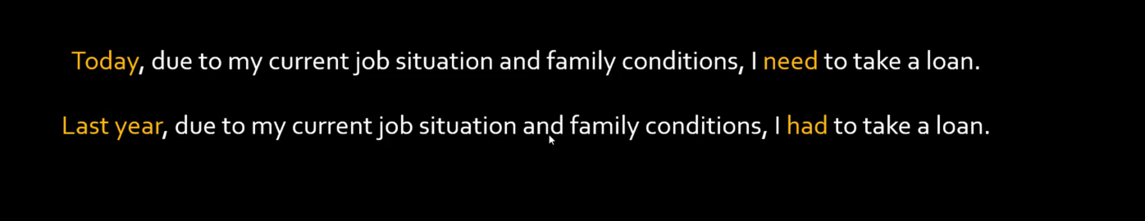

Let’s say, you are using auto complete feature of gmail. When you type ‘Today, due to…..’, it auto completes the sentence by ‘I need to…..’.

As you see, whether to use a word ‘need’ or ‘had’ in later part of the sentence depends on whether you have used ‘Today’ or ‘Last year’ word at the beginning of the sentence.

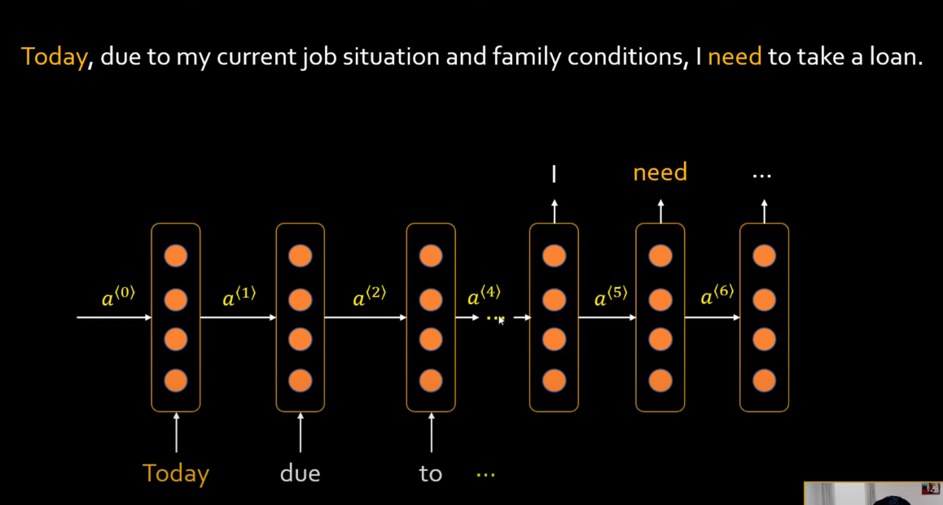

In RNN, we unroll the same layer in time.

As you move further in RNN (e.g. you are on a4), the effect of a1 is reduced. You will have hard time predicting a word ‘need’.

RNNs are said to have very short memory. An effect of ‘Today’ may last till a ‘to’ word, but later on its effect reduces.

Let’s say, it predicted wrong word instead of ‘need’. This error will be backpropagated to change weights of early phases of the layer. By the time, it reaches to earlier phases of the layer, it will face vanishing gradient problem.

We have two solutions, GRU and LSTM. These are special types of RNNs.

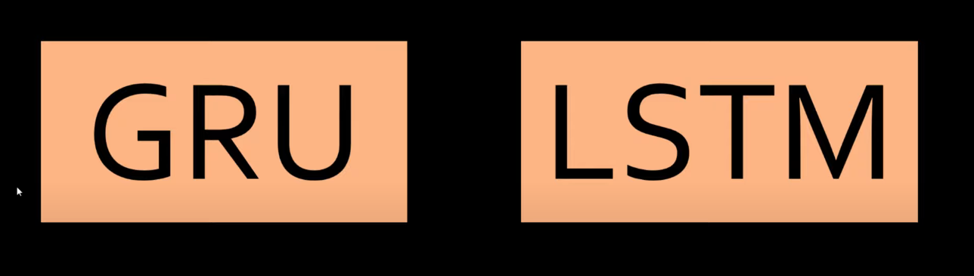

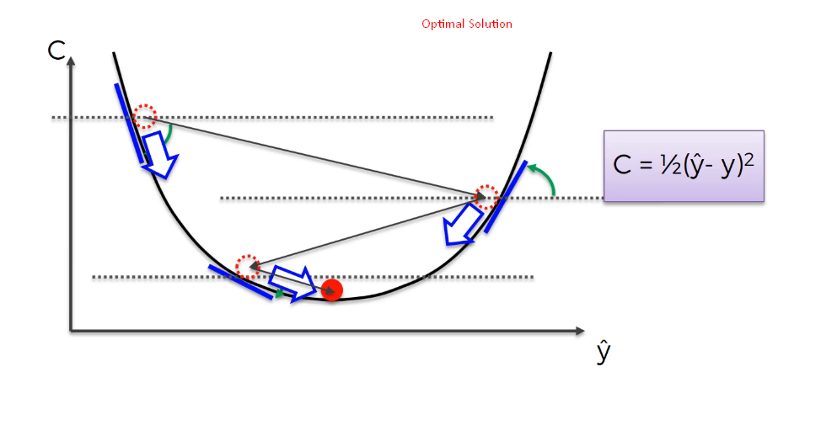

RNN

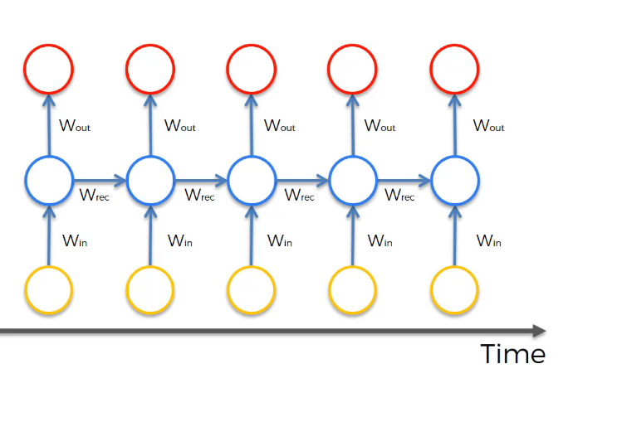

Forward Propagation in RNN

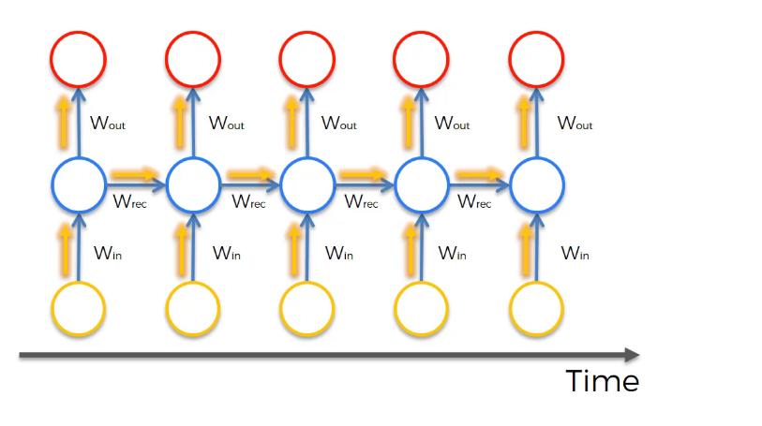

Loss function is calculated at each output.

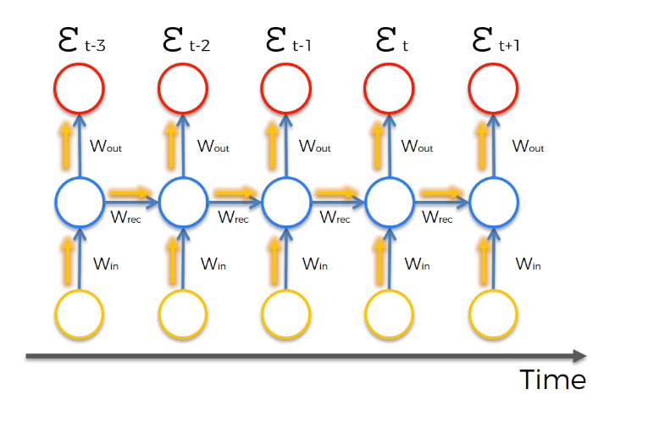

Let’s focus on one at time t.

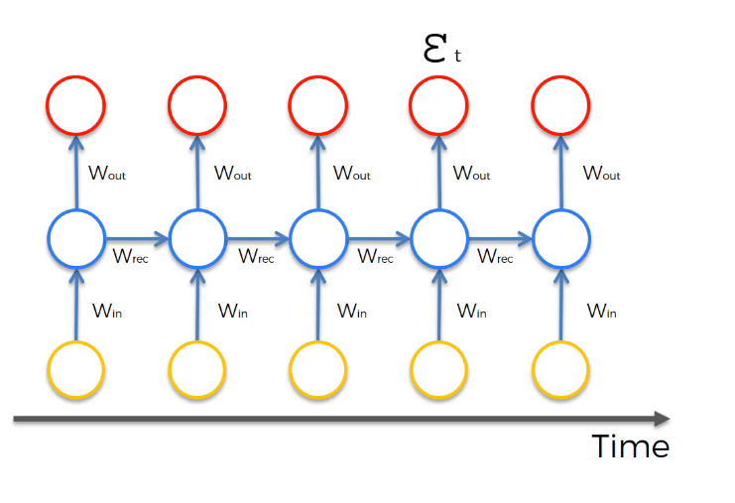

Weights of all the neurons will be updated during back propagation.

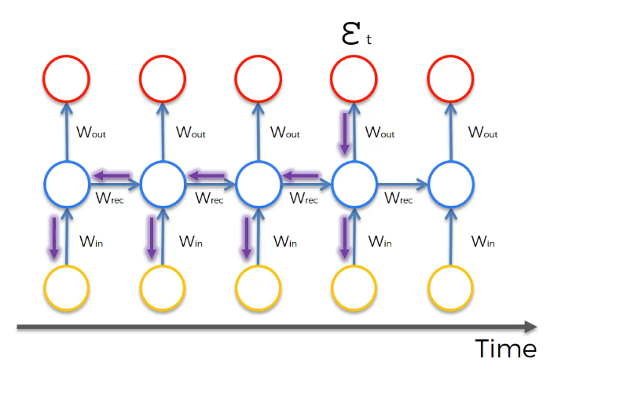

This is where the problem lies that you have to update weights all the way back.

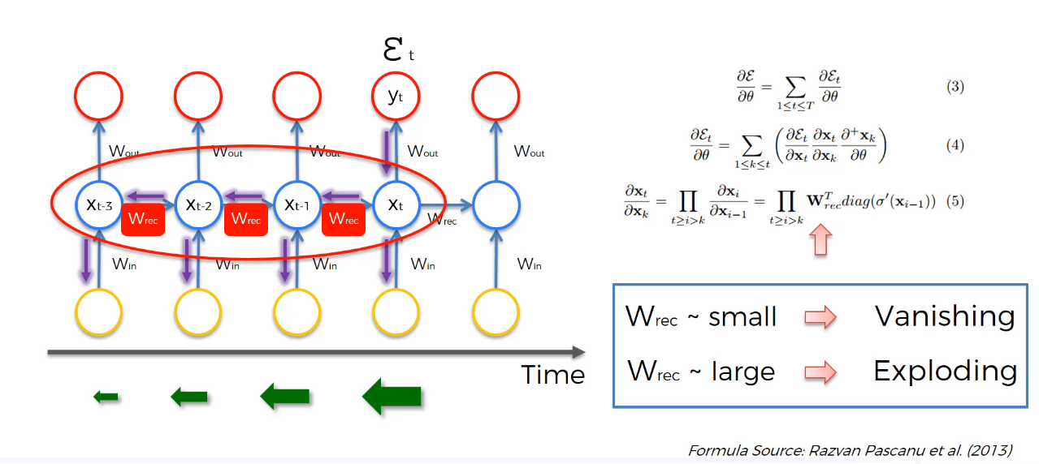

Read ‘Derivative and Gradient’, ‘Chain Rule’, ‘Gradient Descent’ , ‘Gradient Vanishing and Exploding’ from Neural Networks.docx.

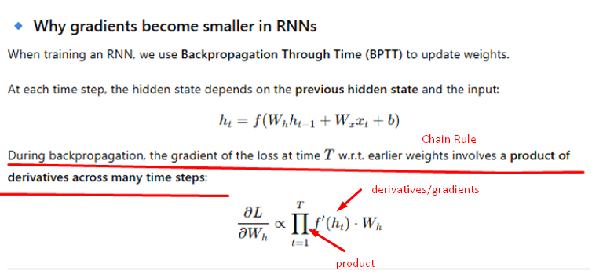

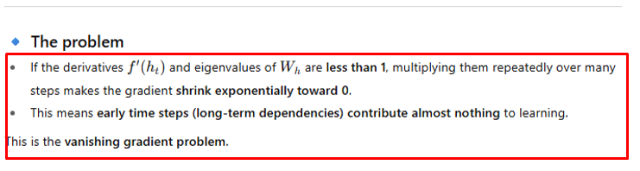

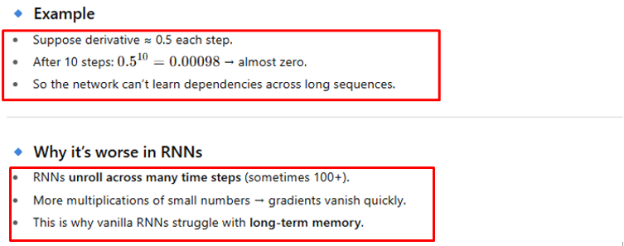

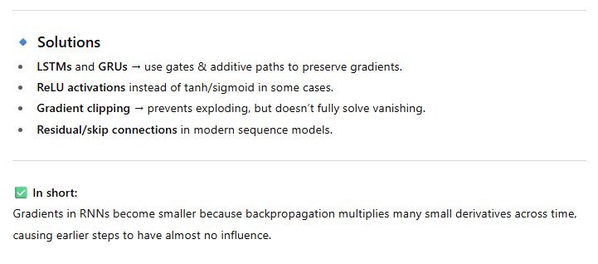

As you back propagate, gradient becomes smaller and smaller. So, weights are not changed much in the earlier parts of RNN. So, these earlier parts are untrained. And outputs of these untrained neurons are used as inputs of further layers. So, training of RNN is happening through many untrained neurons. It’s like a vicious cycle. So, the whole network will not be trained properly. This is what Vanishing Gradient problem in RNN is.

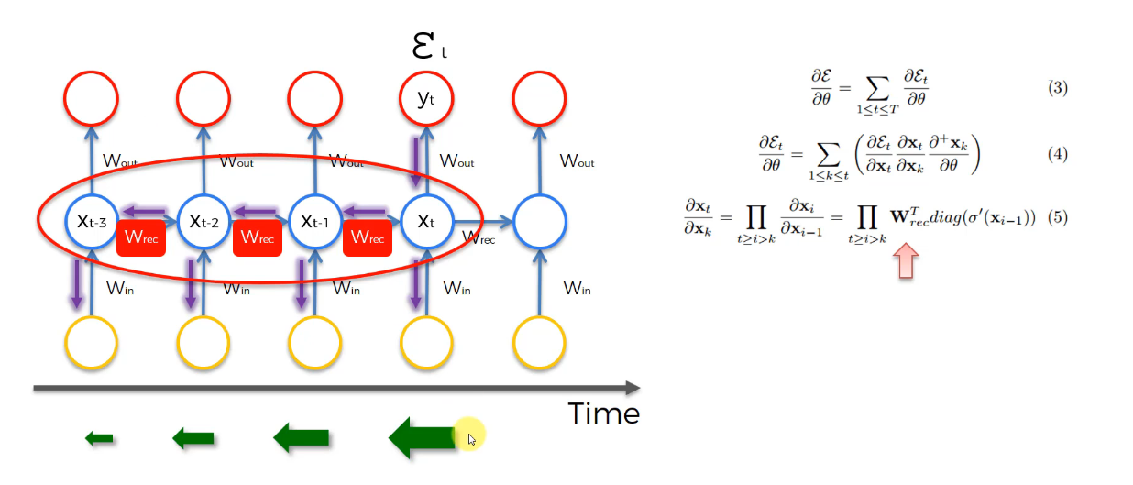

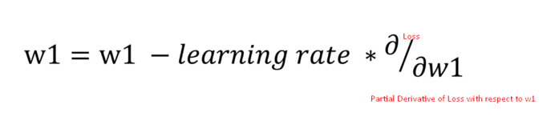

New weight = old weight – learning rate is 0.01 * derivative of Loss with respect to that weight.

d(Loss)/dw1 is a multiplication of many derivatives. If that comes to less than 1, weight will not update much.

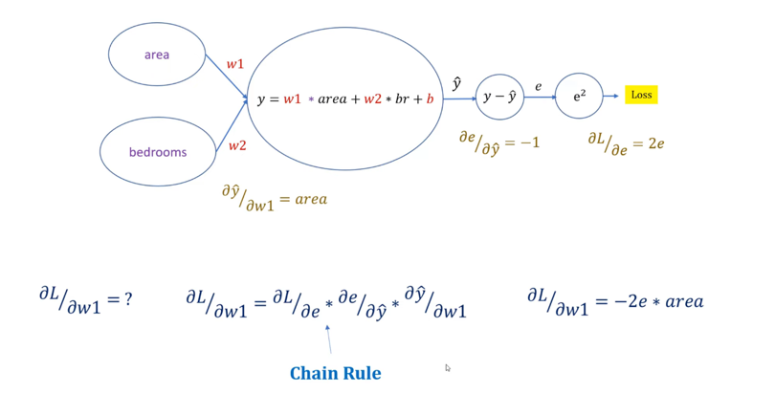

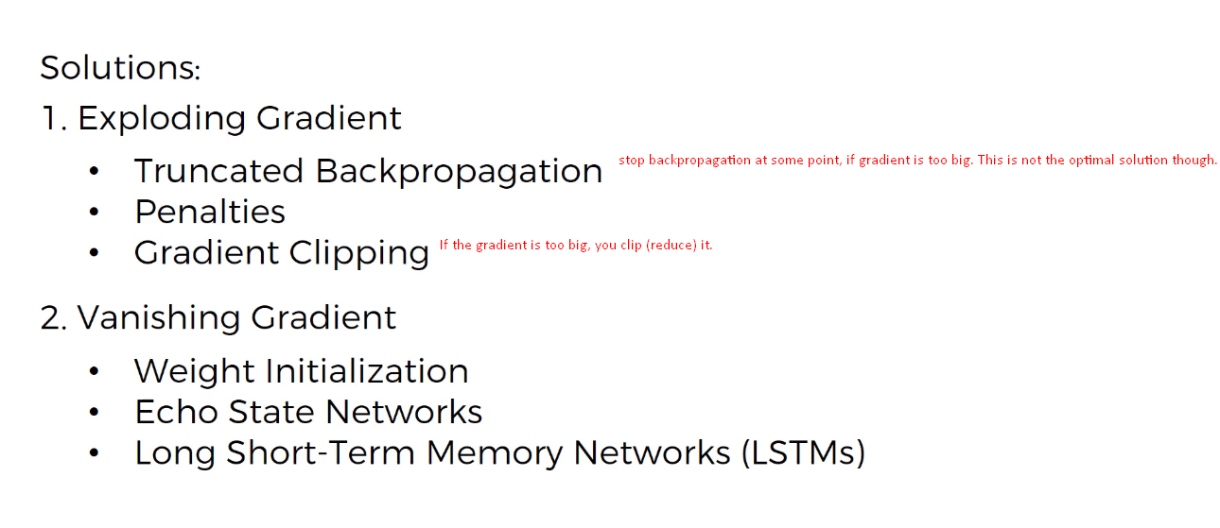

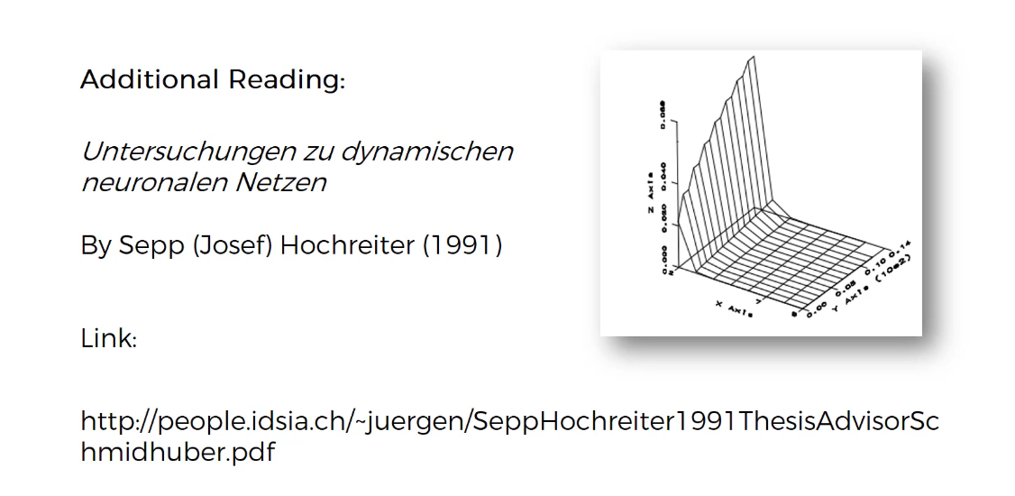

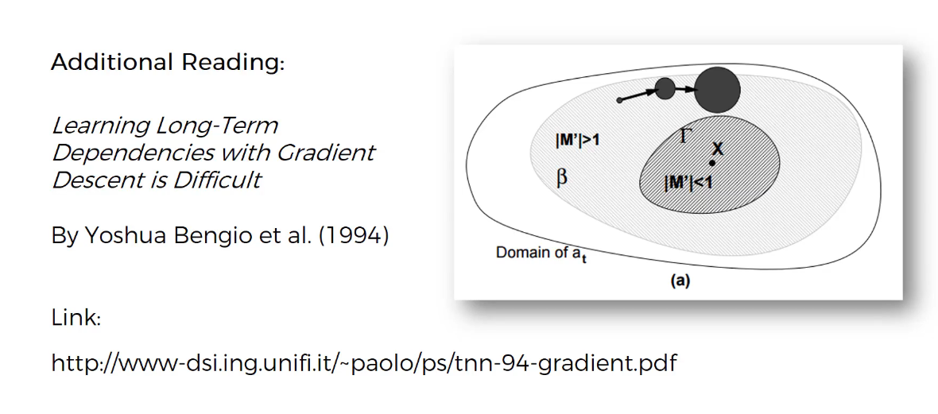

Recommended to read

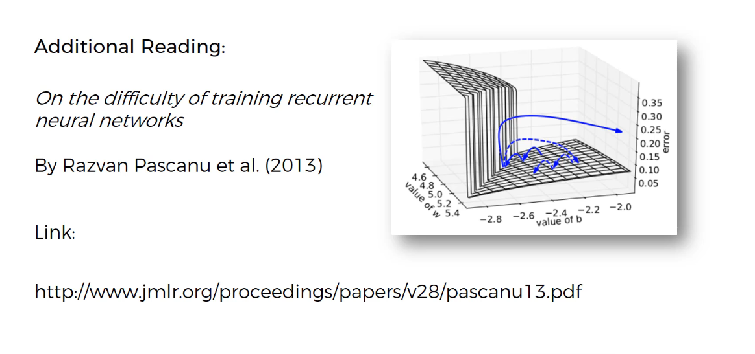

## Long Short-Term Memory (LSTM) architecture

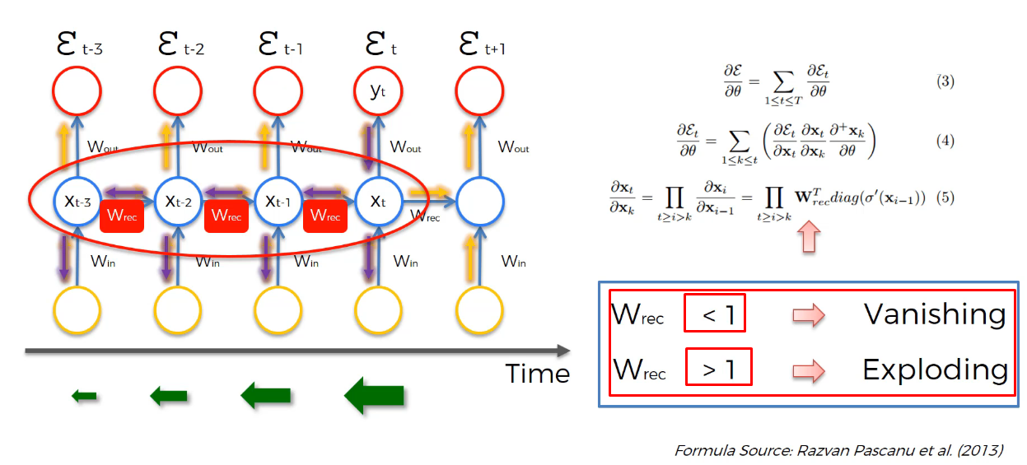

The first thing that comes to mind is to make Wrec = 1

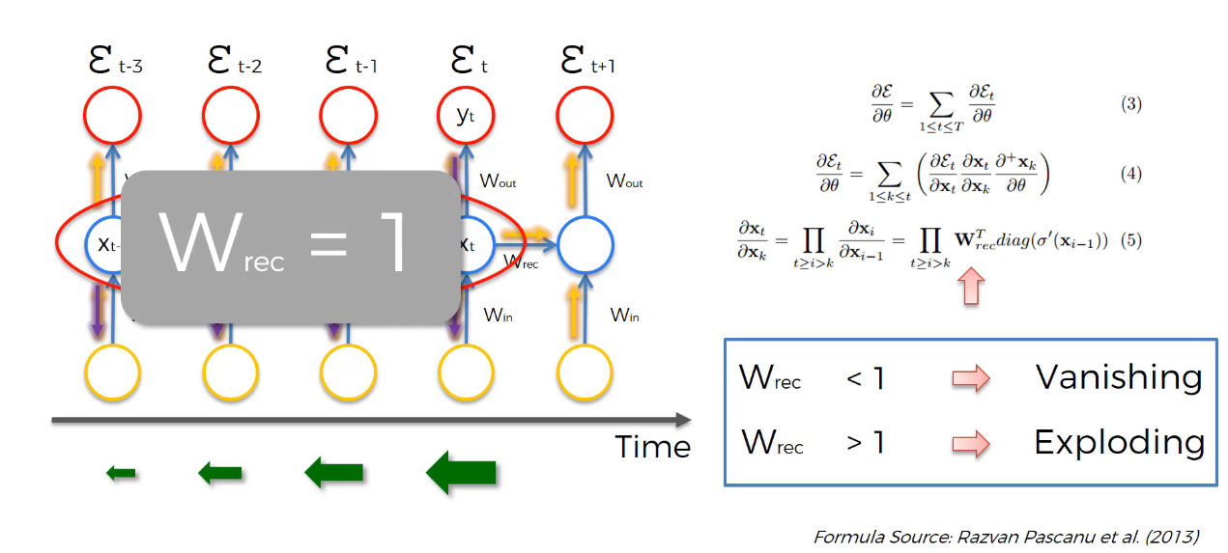

Standard RNN

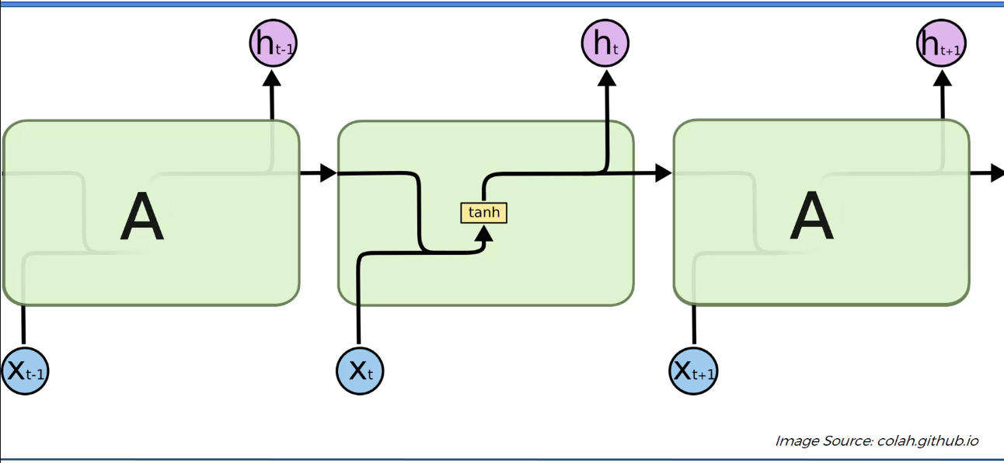

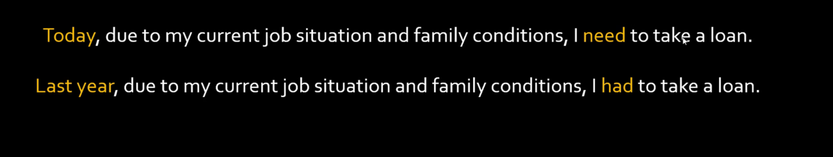

Based on ‘Today’ word, you can predict that ‘need’ word is required. Similarly, based on ‘Last year’ words, you can predict that a word ‘had’ is required.

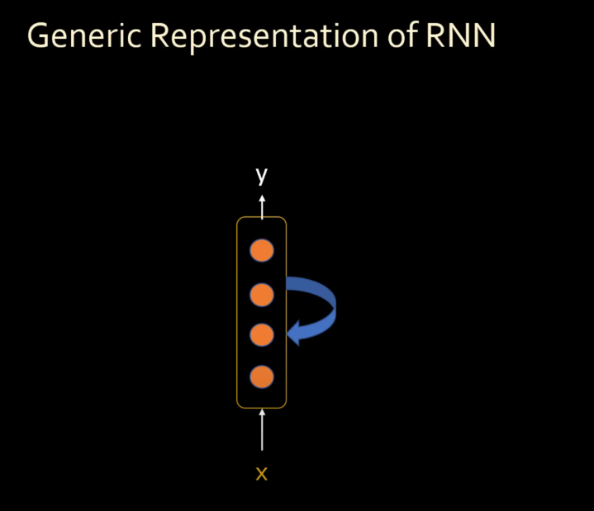

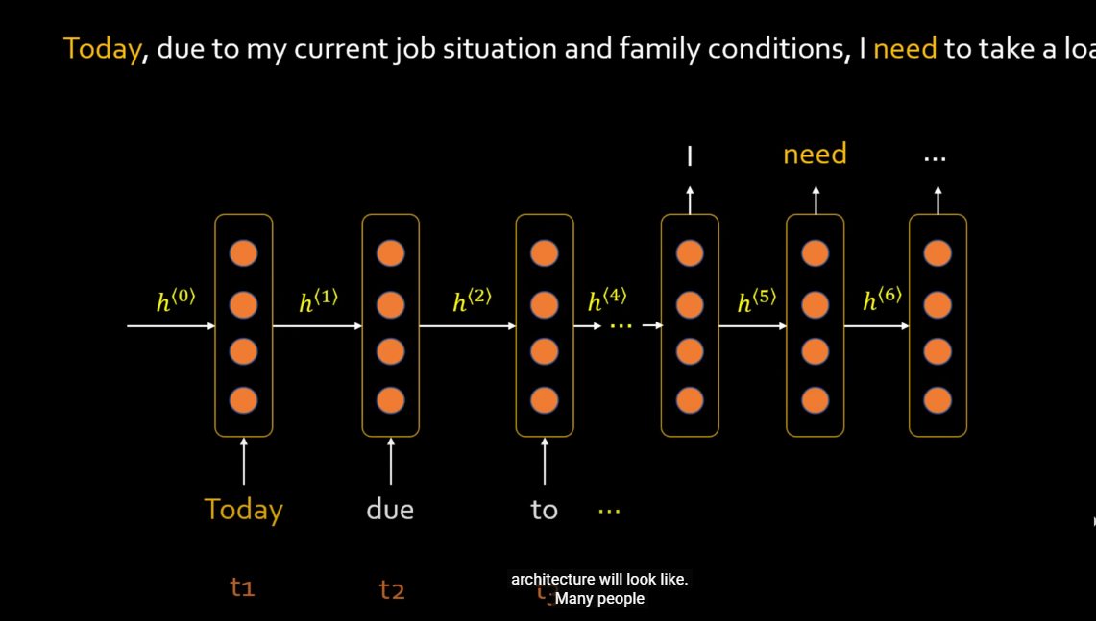

To predict the word ‘need’, it needs to remember the word ‘Today’, which appeared at the very beginning of the sentence. Because of Vanishing gradient problem, traditional RNNs have short term memory. So, do not remember what appeared at the beginning of the sentence. They can just remember a very few previous words.

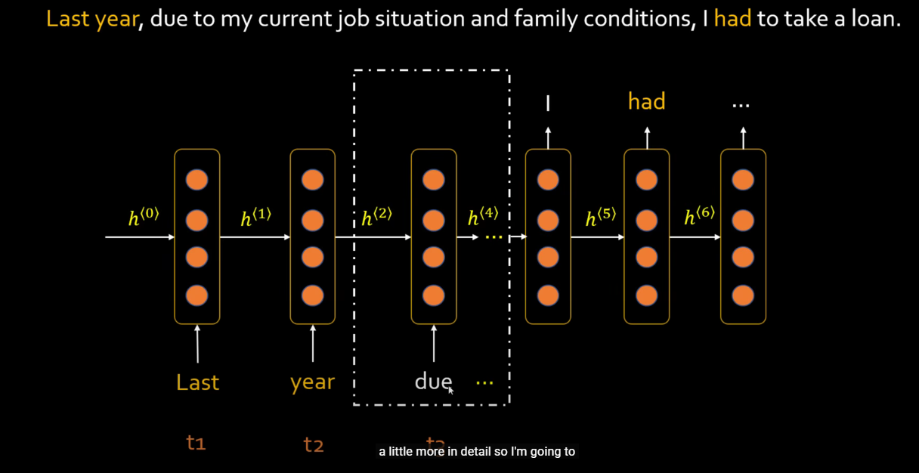

Let’s look at the network layer little more in detail.

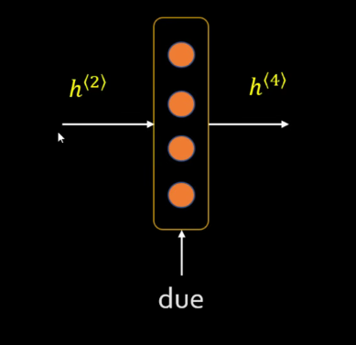

H2 and h4 is nothing but a short term memory.

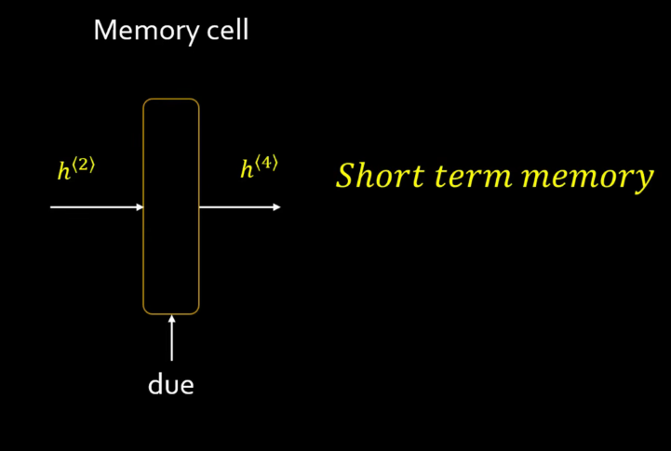

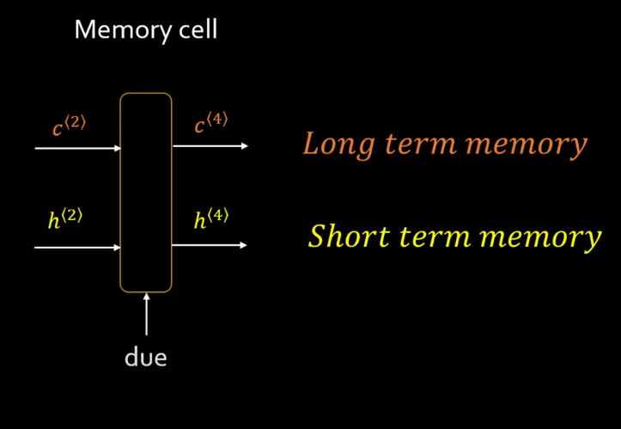

For long term memory, we need to introduce another state ‘c’ (Long term memory).

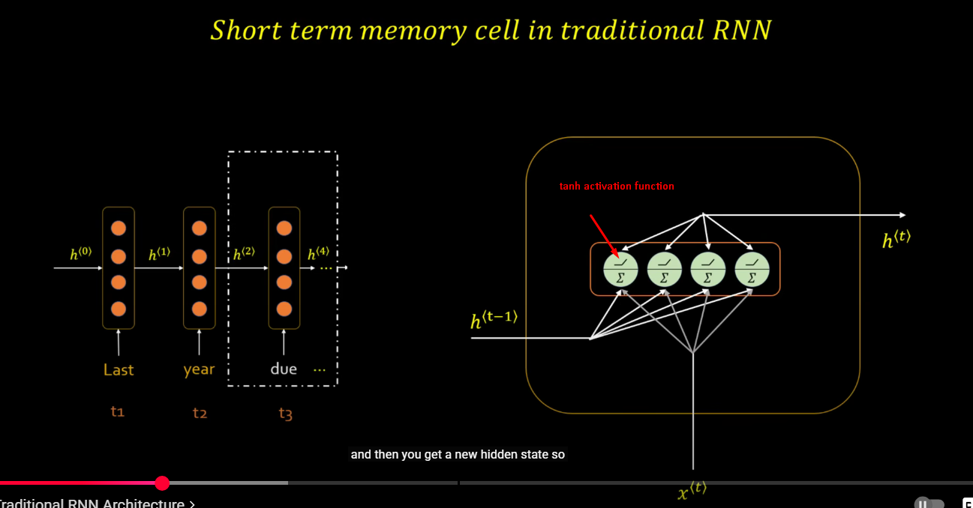

tanh activation function is applied in case of RNN.

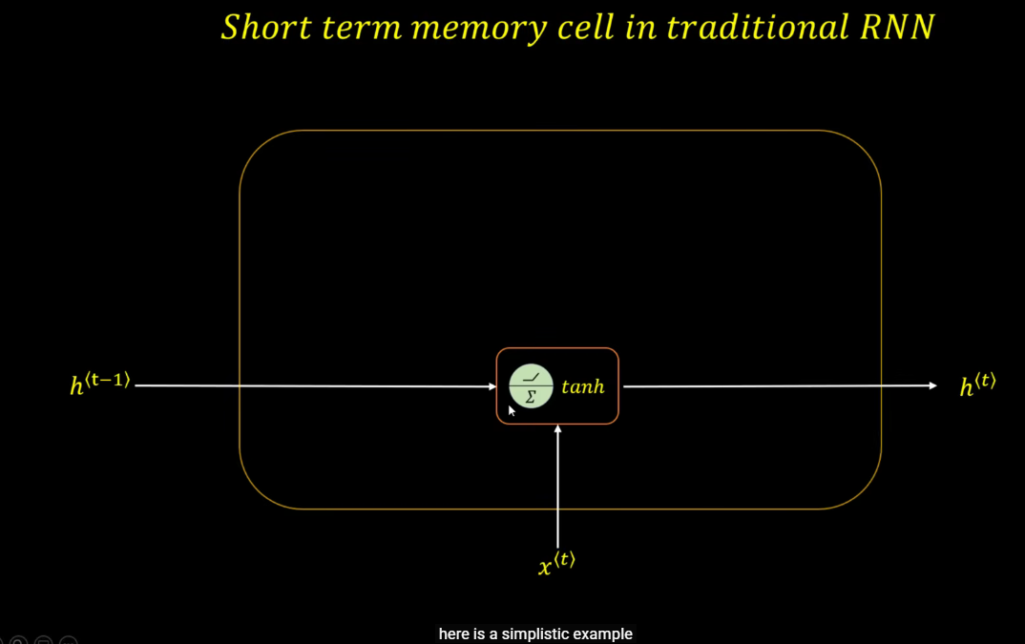

LSTM

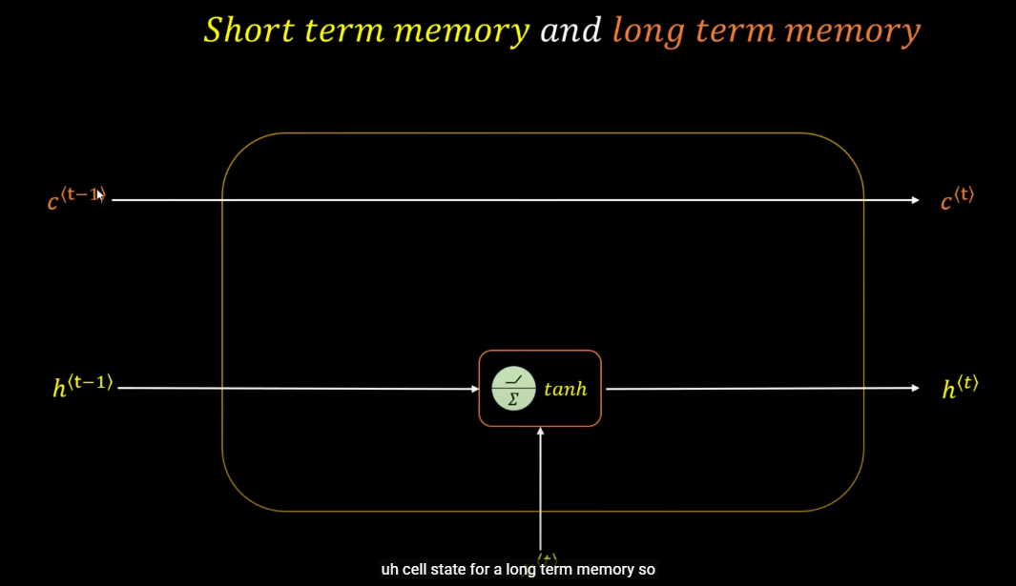

In case of LSTM, we are going to introduce a new state (c ) for long term memory.

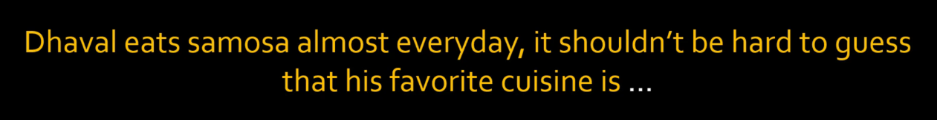

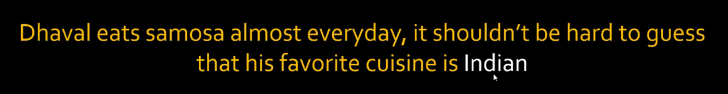

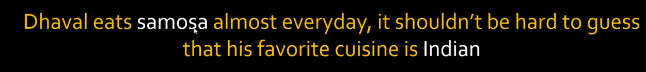

Due to ‘Samosa’ word, we made a decision that it has to be an ‘Indian’ cuisine. So, you are looking for a specific keywords and you can ignore other words.

Let’s look at how our traditional RNN would behave for this sentence.

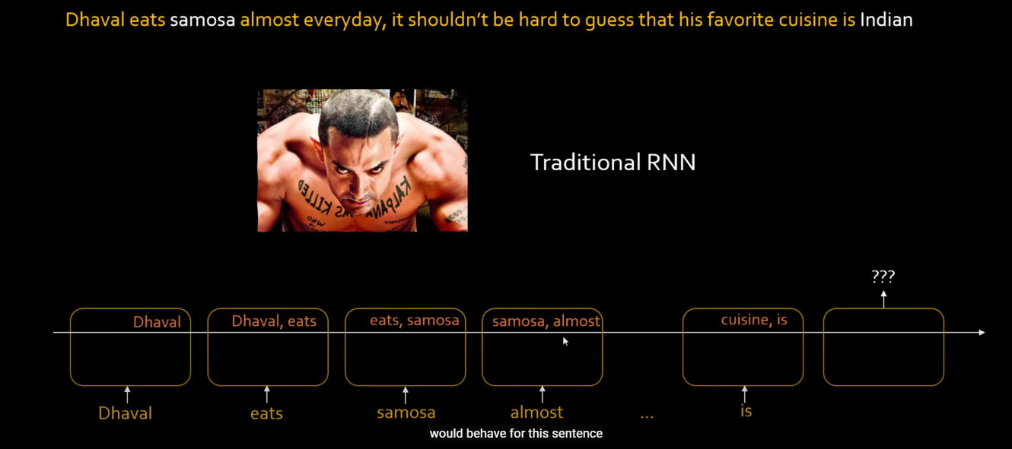

Let’s assume that this RNN can remember only last two words. When you are inputting a word ‘is’, it doesn’t have a knowledge of ‘samosa’. So, for traditional RNN, it is hard to make a guess that the cuisine is ‘indian’.

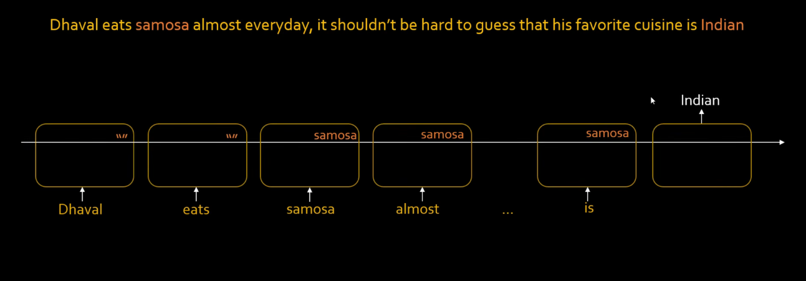

What if, we build a long term memory along with a short term memory in such a way that we store the meaningful words (keywords) in this long term memory. ‘Dhaval’, ‘eats’ are not stored in long term memory, but ‘samosa’ is stored in a long term memory.

Another example:

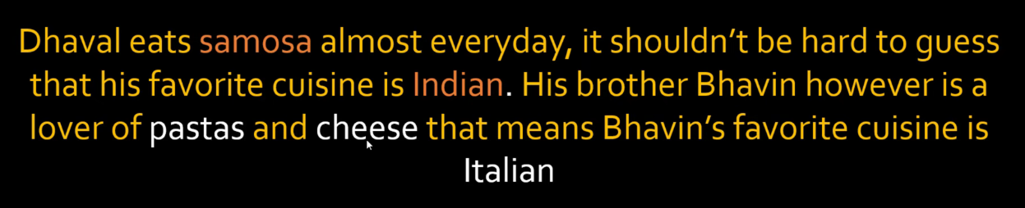

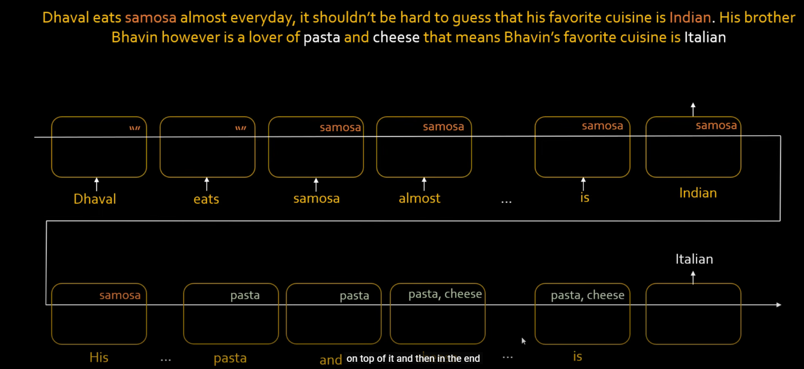

When you encounter a word ‘pasta’, you have to forget a word ‘samosa’ from a long term memory. When you encounter a word ‘cheese’, you have to store it along with a word ‘pasta’ in a long term memory. Based on the memory of ‘pasta’ and ‘cheese’, you predict the word ‘Italian’.

How do you decide to throw away a word ‘samosa’ and keep ‘pasta’ and ‘cheese’ in the long term memory?

All of these things happen during training process of RNN.

Forget Gate in neuron

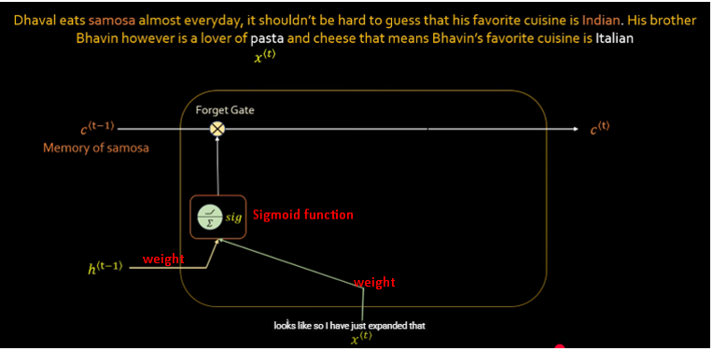

There is ‘Samosa’ in long term memory. If you want to discard it from long term memory, sigmoid function will return an output close to 0. It will be multiplied with a vector (input) coming from c(t-1). If the result is 0(or close to 0), ‘Samosa’ will not be carried forward in long term memory.

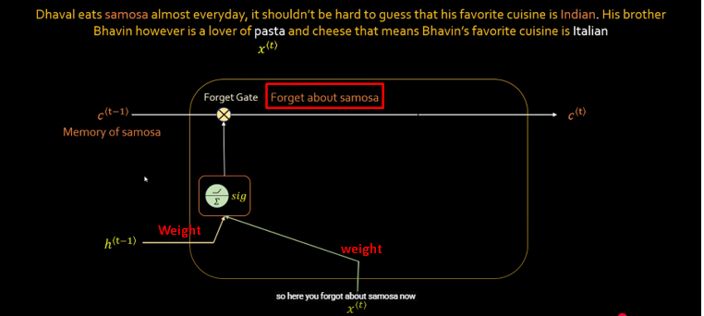

Input Gate

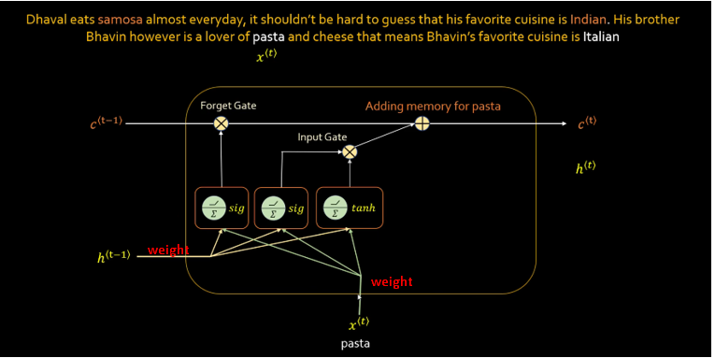

You will use sigmoid and tanh, both functions for input gate. Output from both these functions will be multiplied and the result will decide whether to add ‘pasta’ in long term memory ‘c(t)’.

Output Gate

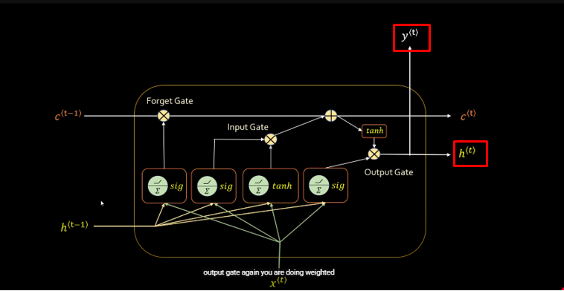

Nice article

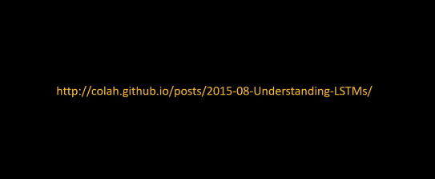

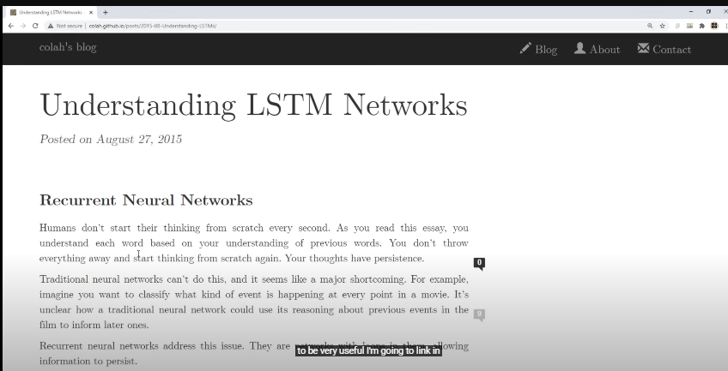

It has all math formulas e.g. how c(t) is calculated.

LSTM

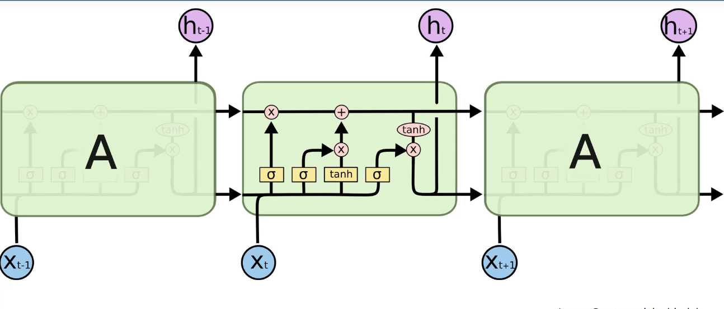

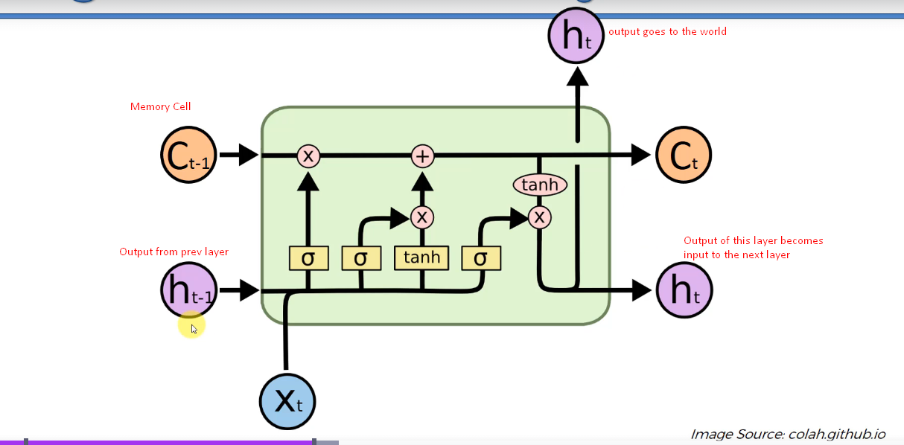

<https://www.youtube.com/watch?v=LfnrRPFhkuY>